Inside the Marshes

A WW1-inspired open-world game.

**Section 1**

Section 1.1 - Player

Section 1.2 - Water & Killboxes

Section 1.3 - Buttons

Section 1.4 - Levers

Section 1.5 - Physics Objects

**Section 2**

Section 2.1 - Death Screen

Section 2.2 - Win Screen

**Section 3**

Section 3.1 - Level 1

Section 3.2 - Level 2

Section 3.3 - Level 3

Section 3.4 - Level 4

# **Section 1 - Mechanics**

## **Section 1.1 - Player**

The player in ‘Inside The Marshes’ is an unnamed character in the woods one day who stumbles upon a small clearing. The primary aim of the character in this game is unclear, but will soon gain a task to collect 3 masks and bring them back to the Church on the Hill.

The player has a few options available to them in the game, these being the following:

* A flashlight, which can be used by pressing ‘F’. Pressing this button will activate the flashlight, producing a cone of light to illuminate in front of the player.

The flashlight has an intensity of 500 and a range of 30. It will slowly trail behind where the player is moving the mouse to.

* Sprinting, holding shift will allow the player to move 50% faster.
* Jumping, the player can jump to get up small obstacles.
* Interaction, the player can press ‘E’ when within 5 in-game units of an item and whilst hovering over an item.

## **Section 1.2 - Masks**

There are three masks available for the player to locate during the game. These masks are split into three distinct areas in which the player is capable of exploring, namely:

* The Trenches
* Execution Site
* Village

The player will be guided along to these locations through different methods, of which they are detailed in the individual level report themselves.

The masks serve as the primary collectible within the game, with the player being tasked with obtaining each one and bringing it back to the Church, with the note in the church detailing the certain locations to go in order to obtain the items they require.

## **Section 1.3 - Flashlight**

The flashlight is a tool usable by the player in order to help them be able to view the area easily, adding a sense of dread to the player as they go along as well due to the limited visibility that they have during the game.

They can press ‘F’ to toggle on and off the game, and they are informed at the beginning of the game by a pop-up that appears, before being disabled after the player exits the trigger box.

# Section 2 - Levels

## **Section 2.1 - The Church**

The Church is the first area that the player will experience when loading into the game.

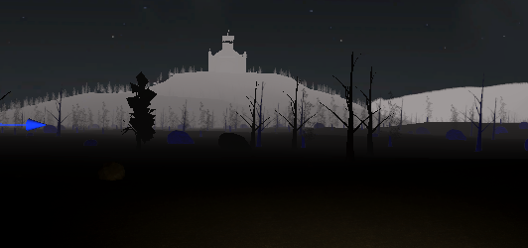

The Church on the Hill is designed to be a landmark location for the player, appearing in their view when they first spawn into the game as the immediate location that they should head towards.

The church interior is designed to guide the player to interacting with the note and associating the statues within the church as part of the ‘end-game’, the final area which they need to head to in order to fully complete the game.

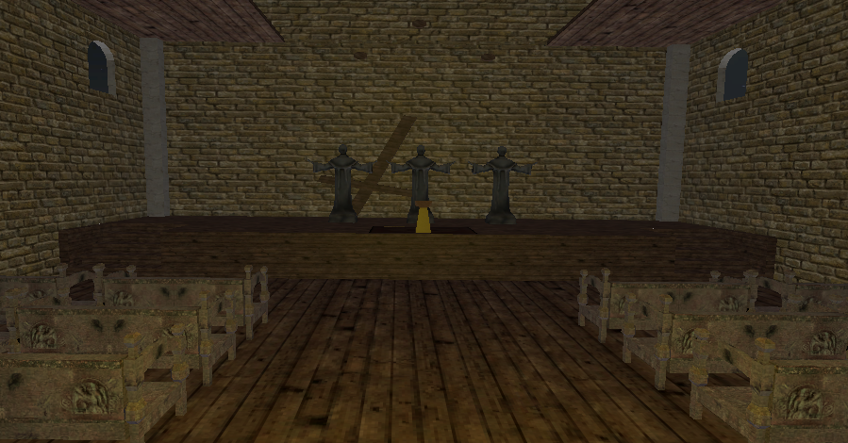

The statues are positioned behind the note to help indicate to the player that they are what needs to be “set free”, with the note detailing the items that the player needs to find and where to go to find them without explicitly telling the player that this is what they need to find.

From here, there are three locations available for the player to discover.

## **Section 2.2 - The Trenches**

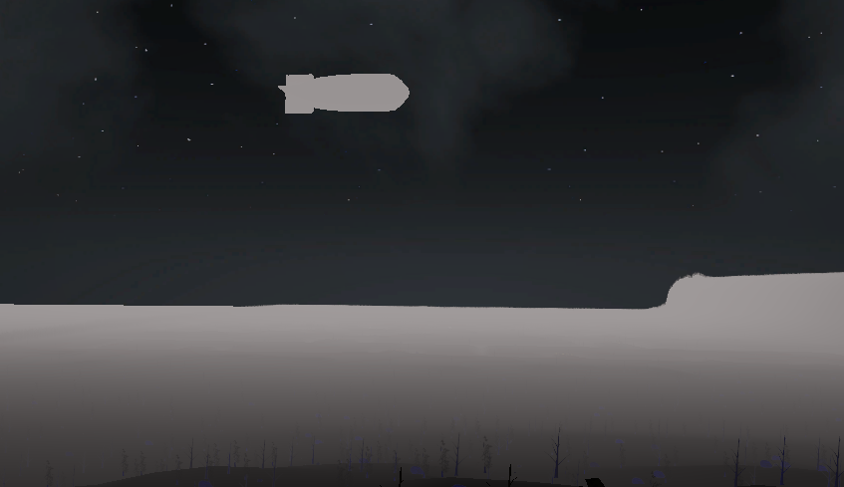

From the church, the player will be able to easily see a blimp in the sky indicating an area of importance to the player and an area they can explore. In addition, the more barren terrain indicates a new area by having limited trees and showcasing itself as entirely different from the place they had been in previously.

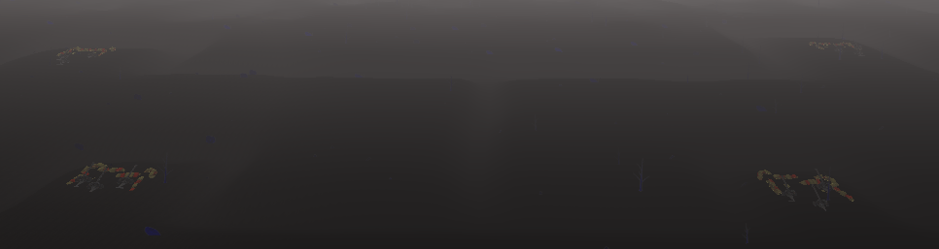

The artillery cannons in this area as well are a minor attempt to funnel the player into heading into the direction of the tank which contains the actual mask, or at least guide their vision in the direction of the light and the tank which contains the mask.

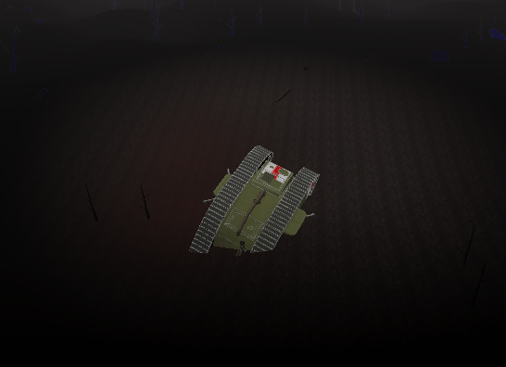

The blimp is overhead of the actual tank itself, attempting to highlight where the actual place the player needs to go is - in addition to this, the area around the tank is highlighted in a light from the blimp, making it more obvious to the player that this is the location that they need to head to.

## **Section 2.3 - Execution site**

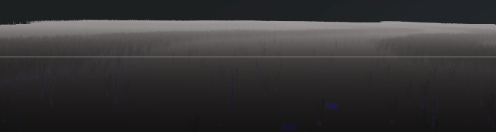

The entrance to the execution site is marked by a clear path in the woods where the trees disperse from their original large formation into an open area where players can move forwards into in order to cross through to help indicate a new area that they can explore.

The path is then guided along to lead them through the forest, the area that they need to continue on clearly shown throughout the entire time they progress through the area.

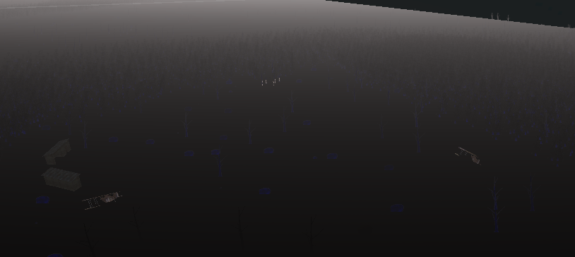

The area then clears out into a full clearing, wherein the player is first met with a fallen biplane. Upon progressing forwards to seeing it properly, they are then able to view the execution of 5 people in the corner of their vision.

The centermost person is brought forward to bring it into the line of sight of the player and to showcase that it is the person in which they need to interact with in order to progress the game.

## **Section 2.4 - The village**



The entrance to the village is marked by a clear path in the hills, indicating a clear path in which the player can take in order to progress towards the village. By having such a drastic change in geometry, the idea is to try and guide them into the pathway so that they can continue onwards into the actual village itself.

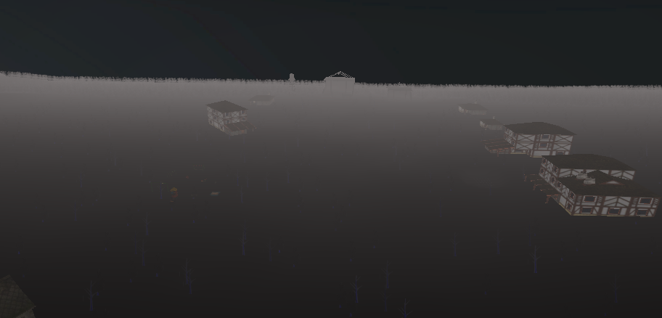

The village itself is littered with buildings, the goal is to guide the player to the buildings, having the main buildings that the player needs to investigate at the end of the pathway. Having them placed at the end of the path directs their attention to it. In the house is the final mask which the player can pick up.